How to Prepare Your Church for Guests
Church Greeter Tips

Our greeter ministry relies on you to be the best greeter you can be in order to serve our guests. Please thoughtfully read these greeter tips and think about how you are doing in these areas, then put the tips into practice. Save this sheet to look back on later to see how you have improved.

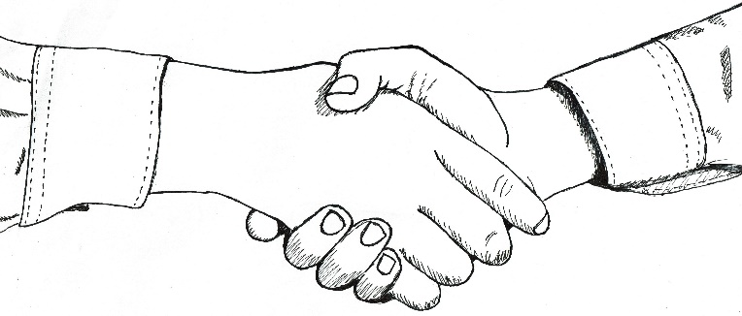

1. Pray
Take some time before the doors open to pray that your heart would be sensitive to the Holy Spirit. Pray that you would allow yourself to be used of Him.

2. Prepare yourself
Sometimes when we’ve had a hard week, or a difficult morning, we let that creep into our interactions. Guests will easily pick up on that, and it will set the tone for their visit. Make sure to clear these thoughts from your head. Realize that you are the first person guests will encounter at our church and prepare yourself appropriately. This could be the first time they are presented with the gospel, and you certainly do not want to be the one who hinders them from accepting Christ.

3. Greet guests tactfully
Greet everyone who comes through the door with a smile. If you know the person’s name, use their name when you greet them. Offer your hand and shake firmly. If you think someone might be a guest, greet them in a tactful manner.

Don’t say:
- “I’ve never seen you here before. Are you a new?”
- “Hi, what’s your name?”

Instead say:
- “Hello, I don’t believe we have met. My name is _________. May I have your name?”
- “Good morning! I’m glad you came to worship with us today.” Extend your hand and introduce yourself.

4. Use names in conversation
When you talk with guests, address them by name. It will make your conversation friendlier as well as help you remember their name the next time you see them. If you end up forgetting their name, address this at the beginning of the conversation. The longer you wait to ask their name the more awkward it will be when you do ask. You can say something to the effect of “I know your name, but I am drawing a blank right now. Do you mind helping me out?” Most people will understand and will gladly remind you of their name.

5. Introduce guests
Introduce guests to other members of the church. Do your best to make them feel welcome and at home. Do not shut guests out of your conversations with other church members. Look for ways to include them and make them feel like they belong.

6. Help guests
Show guests around the facility. If they have children, be sure to show them where the classrooms and nursery are located. Tell them a little about the church, ministries, and classes available for them to attend. Ask your guests if there is anything you can do for them.

7. Visit with guests
Before or after the service, invite guests to visit with you for coffee in the foyer. Get to know your guests and let them get to know you.

8. Follow up
As guests leave, let them know you are happy to have met them. Tell them what a pleasure it was to have them visit, and that you hope to see them back soon. Take time during the week to write a postcard to any guests you met. Reiterate how nice it was to have them visit.

